Computer Science The Board Lab – THE BLOCK Lab Value - 100

Lab Goal : This lab was designed to teach you more object oriented programming and how to write a very simple game.

Lab Description : Complete the code for the Block class located in Block.java. Block implements the Locatable interface. Block must implement all of the Loctable methods. Test Block using the BlockTestOne.java and BlockTestTwo.java files. The Block class will be used to make a Board. The Block class stores position, size, and color properties.
Files Needed ::
Locatable.java
Block.java
BlockTestOne.java
BlockTestTwo.java
Tester.java

public class Block implements Locatable
{
private int width; //width of the block
private int height; //height of the block

private int xPos; //x position of the block
private int yPos; //y psoition of the block

private Color color; //color of the block

public Block(){

}
Sample Output ( BlockTestOne.java )
100 150 10 10 java.awt.Color[r=0,g=0,b=0]
50 50 30 30 java.awt.Color[r=0,g=0,b=0]
350 350 15 15 java.awt.Color[r=255,g=0,b=0]
450 50 20 60 java.awt.Color[r=0,g=255,b=0]

//other Block constructors not shown

//other modifiers not shown

public void draw(Graphics window){
window.setColor(color);
window.fillRect(getX(), getY(), getWidth(), getHeight());
}
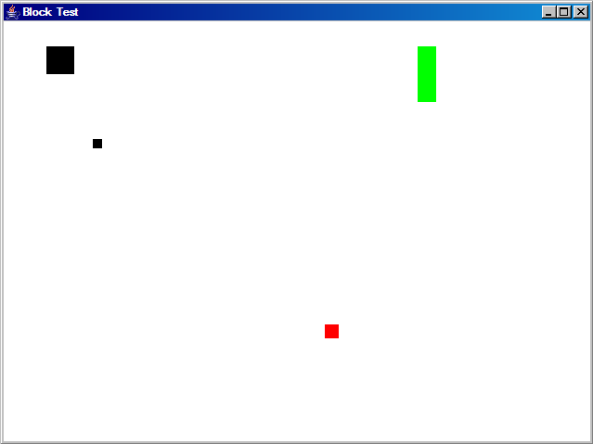

//other accessors not shown

}

